Cylinder-Based Subtraction

Definition
# Source: AI Source: Provided by: [Data Path: Persons Table -> ID Column: 1, Name_En Column: Motasem Essam] -> From: [ChatGPT] on [7/25/2026]
Cylinder-Based Subtraction is a type of composite solid formed by removing one or more portions from an original cylinder or cylinder-based solid.
The removed portions may have different geometric shapes, dimensions, and orientations. They can be removed from the circular bases, curved lateral surface, central axis, or interior of the original cylinder.
The removed portions may include:
- Smaller cylinders.
- Partial cylinders.
- Cubes and rectangular prisms.
- Cones and truncated cones.
- Pyramids.
- Spheres and hemispheres.
- Other geometric shapes.
Examples include:
- A cylinder with a smaller cylindrical through-hole.
- A cylinder with a blind cylindrical cavity.
- A cylinder with a rectangular slot.
- A cylinder with a conical depression.
- A cylinder with a spherical cavity.
- A cylinder with multiple cutouts.

Simple Definition
# Source: AI Source: Provided by: [Data Path: Persons Table -> ID Column: 1, Name_En Column: Motasem Essam] -> From: [ChatGPT] on [7/25/2026]
Cylinder-based subtraction is the process of removing one or more geometric portions from a cylinder to create a modified solid.

Geometric Representation
# Source: AI Source: Provided by: [Data Path: Persons Table -> ID Column: 1, Name_En Column: Motasem Essam] -> From: [ChatGPT] on [7/25/2026]
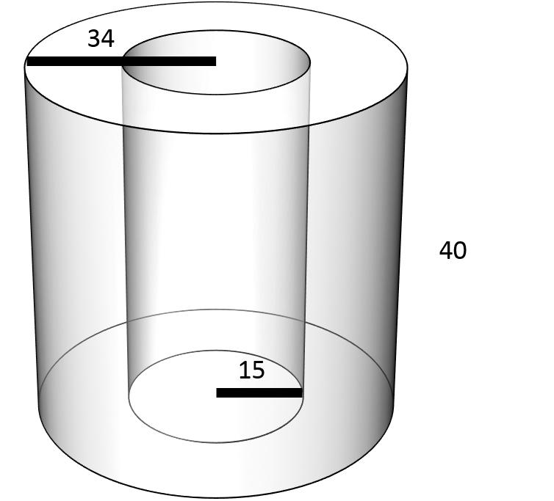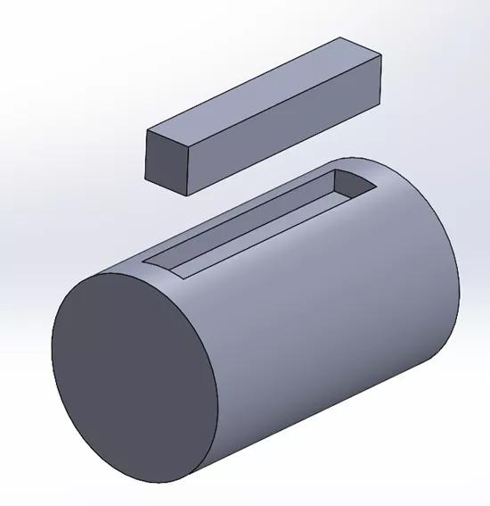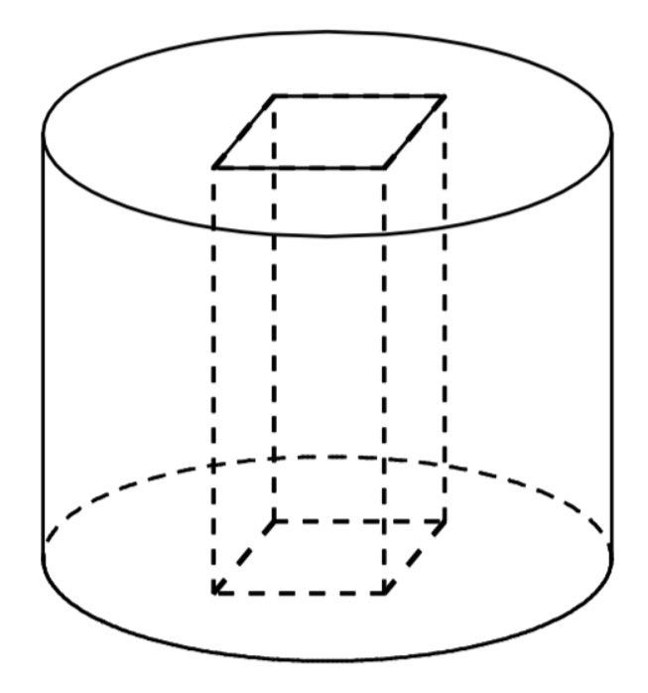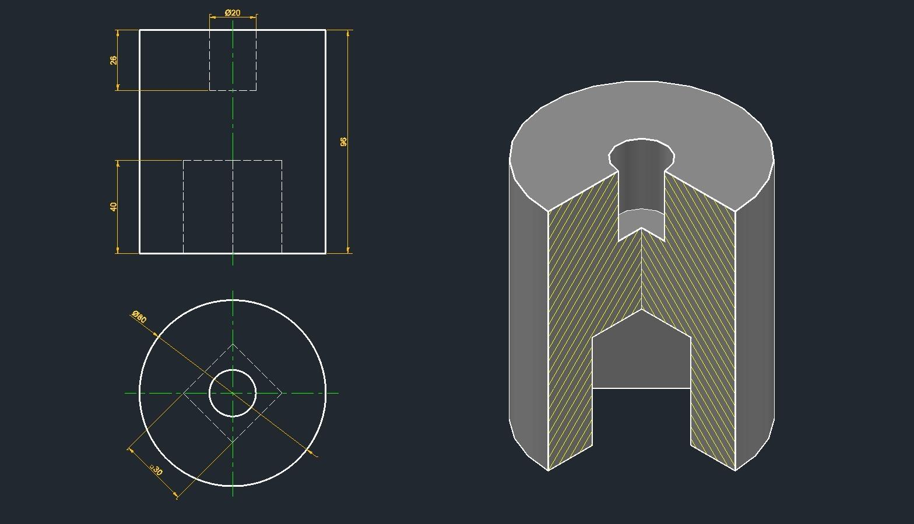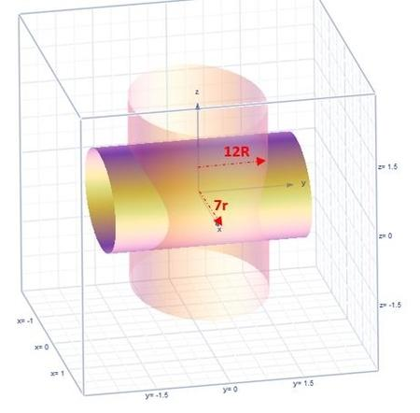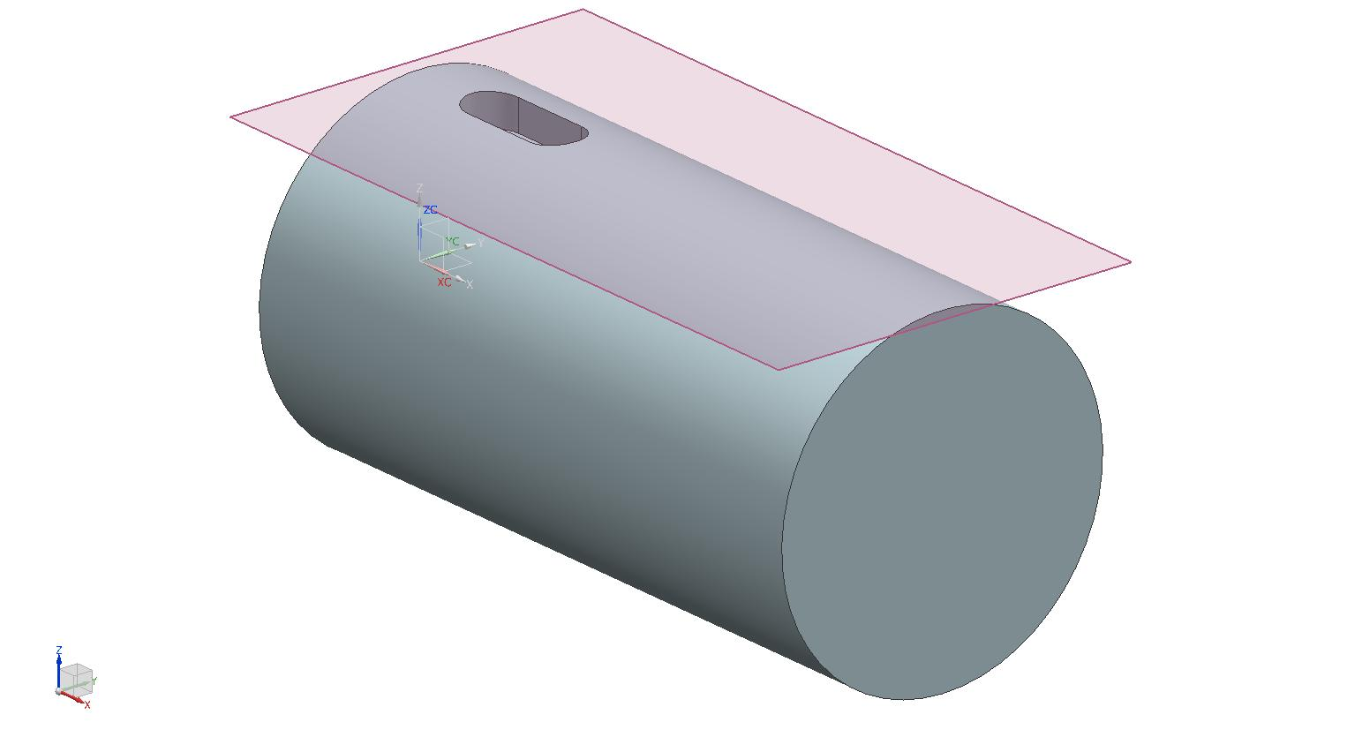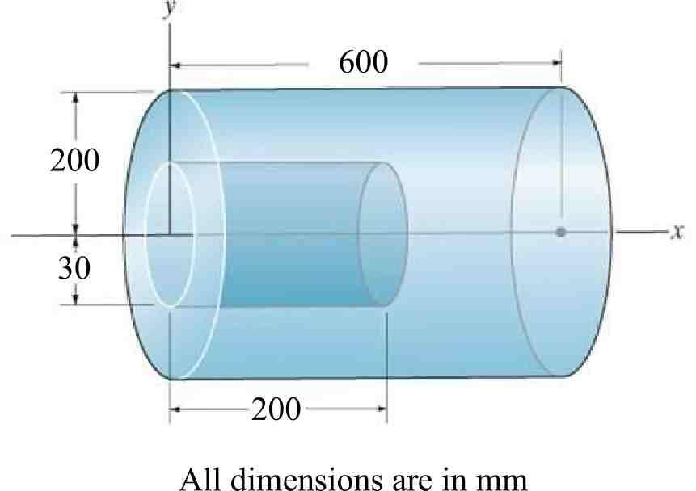
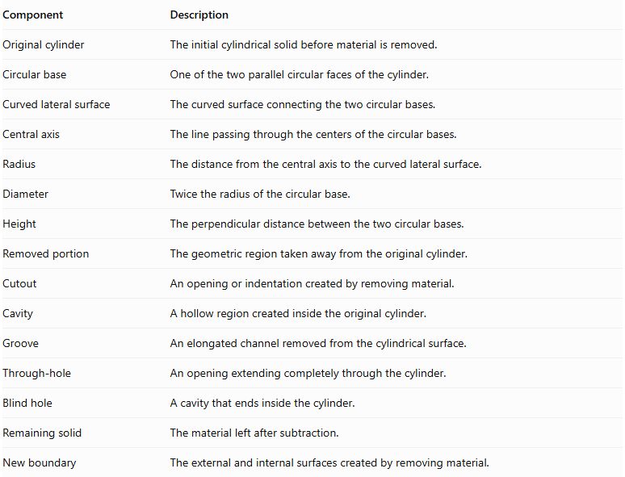
Component | Description
Original cylinder | The initial cylindrical solid before material is removed.
Circular base | One of the two parallel circular faces of the cylinder.
Curved lateral surface | The curved surface connecting the two circular bases.
Central axis | The line passing through the centers of the circular bases.
Radius | The distance from the central axis to the curved lateral surface.
Diameter | Twice the radius of the circular base.
Height | The perpendicular distance between the two circular bases.
Removed portion | The geometric region taken away from the original cylinder.
Cutout | An opening or indentation created by removing material.
Cavity | A hollow region created inside the original cylinder.
Groove | An elongated channel removed from the cylindrical surface.
Through-hole | An opening extending completely through the cylinder.
Blind hole | A cavity that ends inside the cylinder.
Remaining solid | The material left after subtraction.
New boundary | The external and internal surfaces created by removing material.

Types of Cylinder-Based Subtraction

Cylindrical Subtraction from a Cylinder
# Source: AI Source: Provided by: [Data Path: Persons Table -> ID Column: 1, Name_En Column: Motasem Essam] -> From: [ChatGPT] on [7/25/2026]
This type is formed by removing a smaller cylindrical portion from an original cylinder.
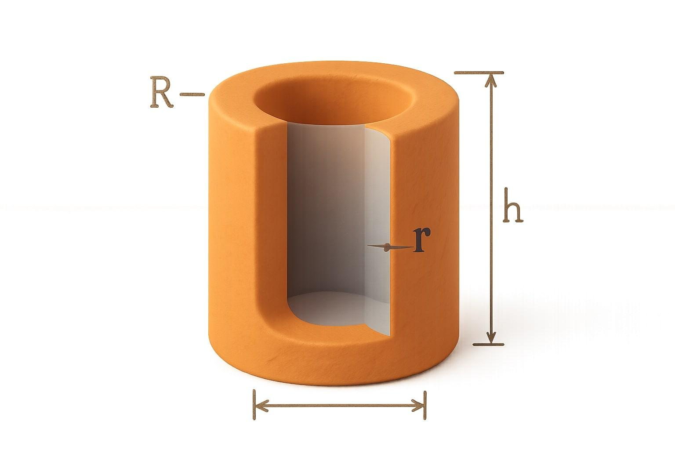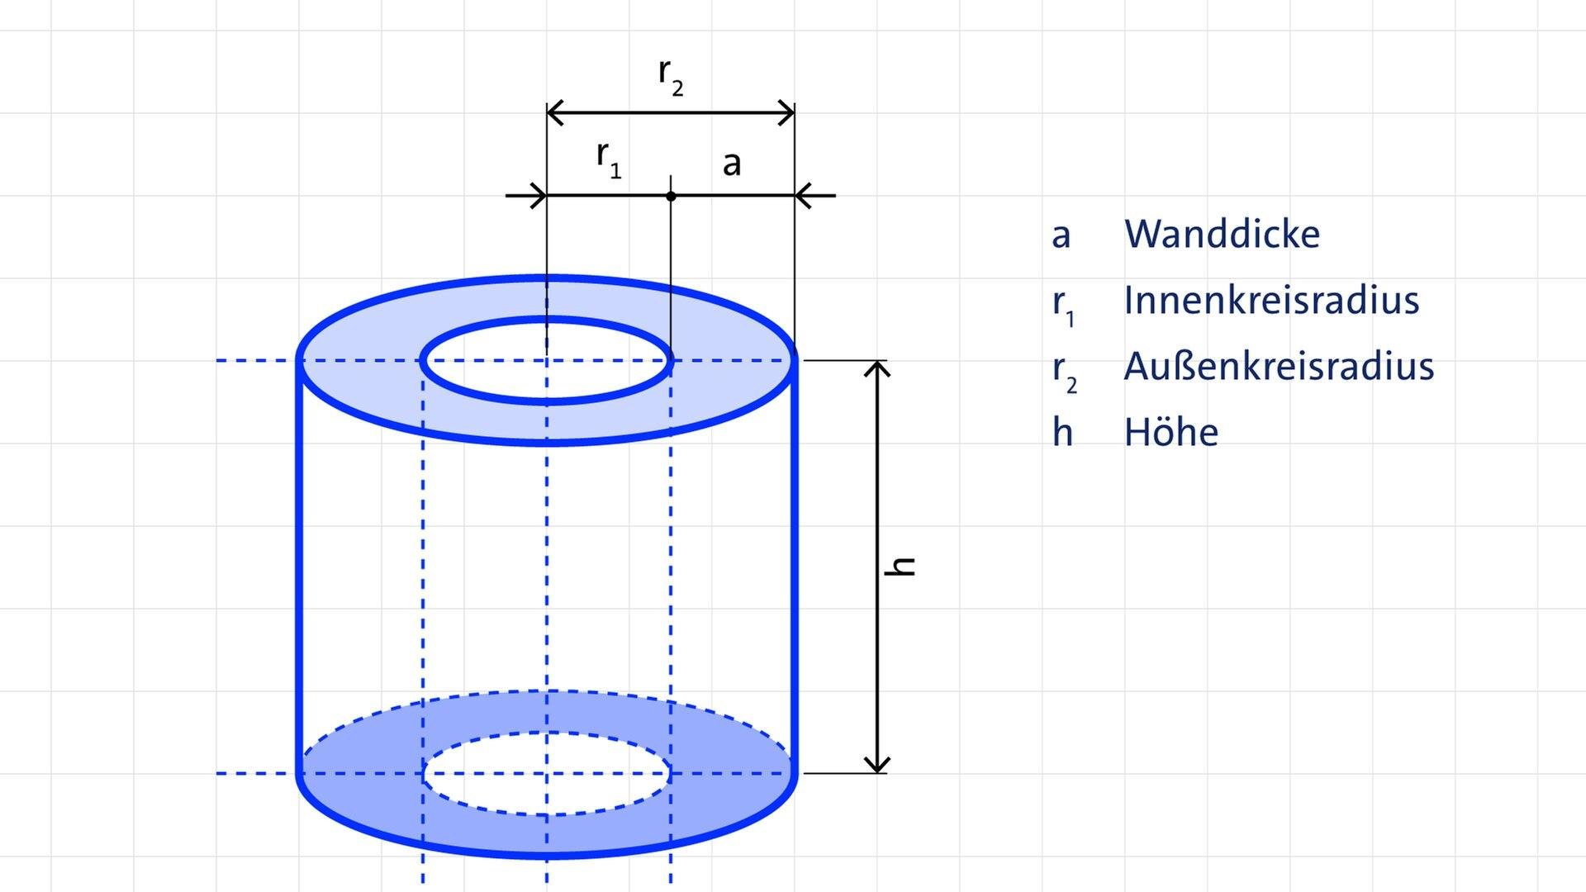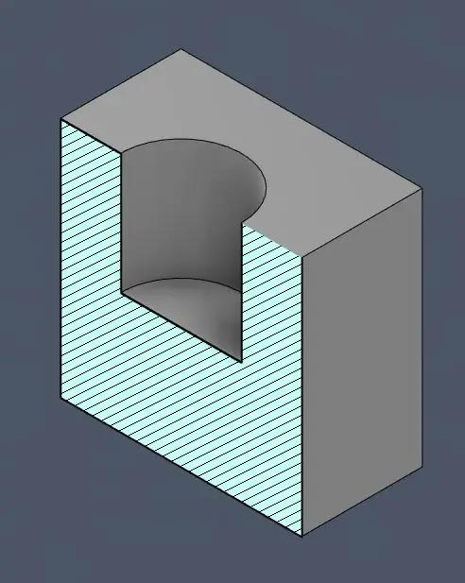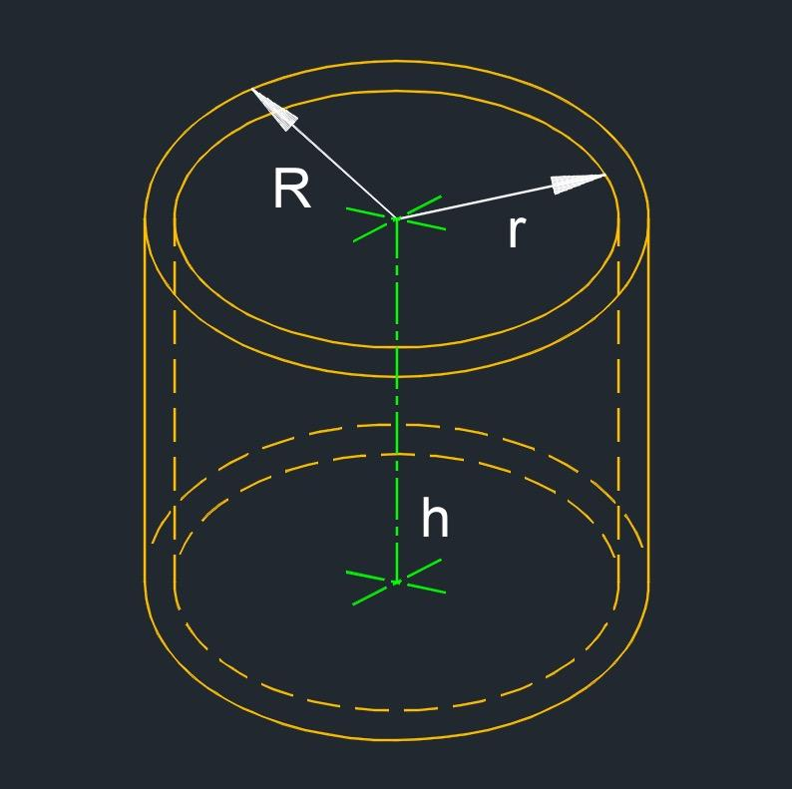
Examples:
- Creating a coaxial cylindrical through-hole.
- Creating a blind cylindrical cavity.
- Removing an off-center cylindrical section.
- Creating multiple cylindrical holes.
- Producing a hollow cylindrical structure.

Rectangular Prism Subtraction from a Cylinder
# Source: AI Source: Provided by: [Data Path: Persons Table -> ID Column: 1, Name_En Column: Motasem Essam] -> From: [ChatGPT] on [7/25/2026]
This type is formed by removing a rectangular prism or cuboid-shaped portion from an original cylinder.
Examples:
- Removing a rectangular slot from the curved surface.
- Creating a rectangular cavity through a cylinder.
- Removing a rectangular section from one end.
- Creating a longitudinal rectangular groove.

Triangular Prism Subtraction from a Cylinder
# Source: AI Source: Provided by: [Data Path: Persons Table -> ID Column: 1, Name_En Column: Motasem Essam] -> From: [ChatGPT] on [7/25/2026]
This type is formed by removing a triangular prism-shaped portion from an original cylinder.
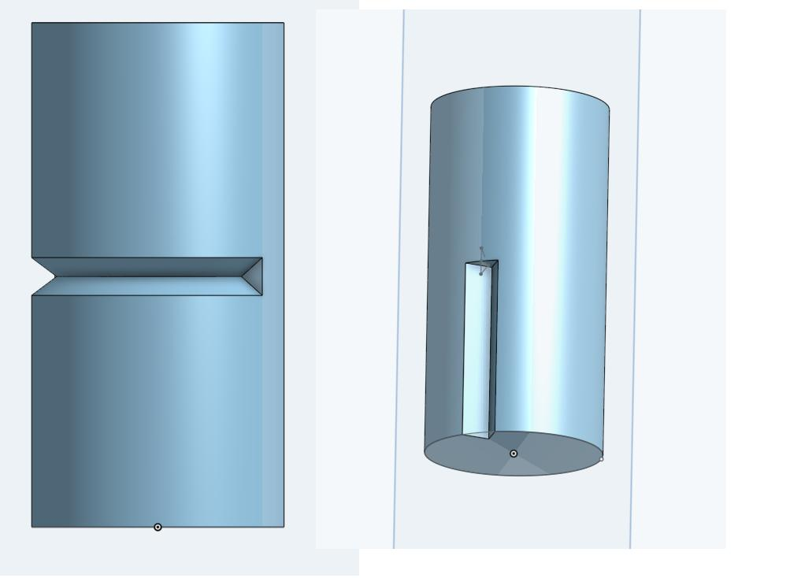
Examples:
- Creating a V-shaped longitudinal groove.
- Removing a triangular section from the side.
- Creating a triangular channel.
- Removing a triangular portion from an end region.

Conical Subtraction from a Cylinder
# Source: AI Source: Provided by: [Data Path: Persons Table -> ID Column: 1, Name_En Column: Motasem Essam] -> From: [ChatGPT] on [7/25/2026]
This type is formed by removing a cone-shaped or truncated-cone-shaped portion from an original cylinder.
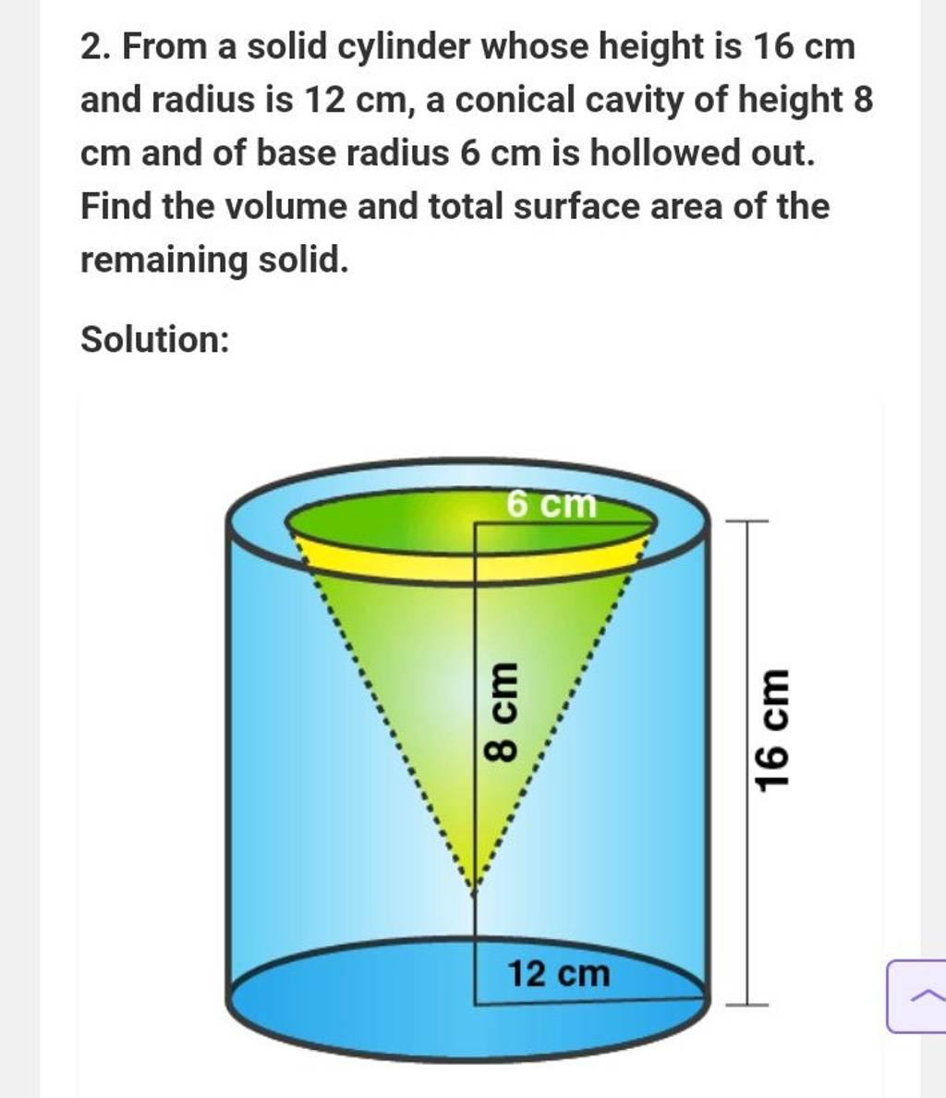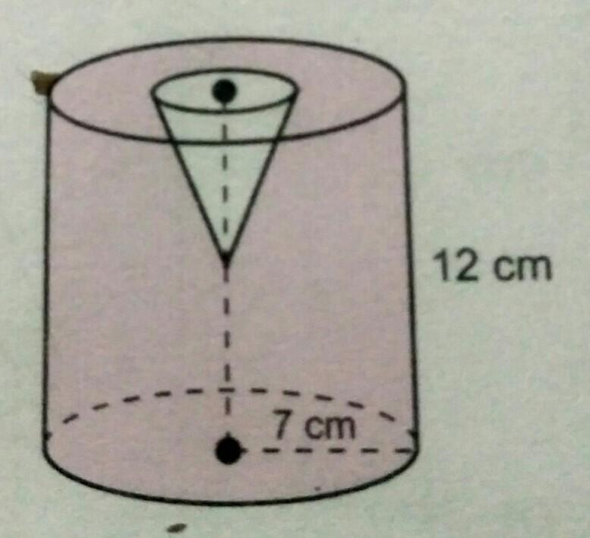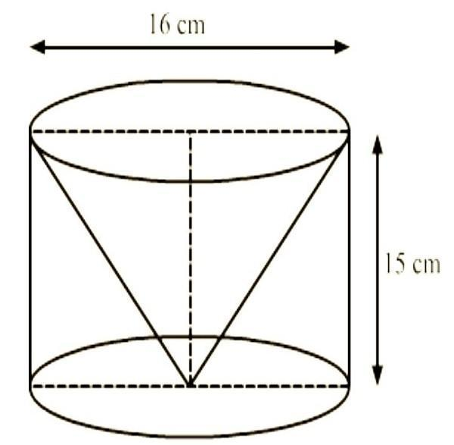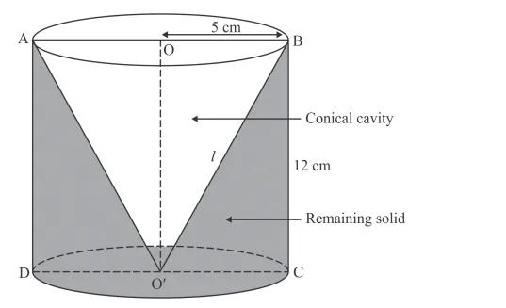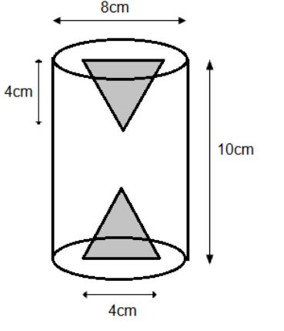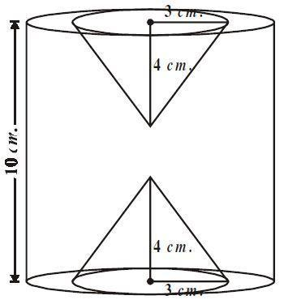
Examples:
- Creating a conical depression on a circular base.
- Removing a conical cavity from the top.
- Creating a tapered opening.
- Removing a truncated-cone-shaped portion.

Pyramidal Subtraction from a Cylinder
# Source: AI Source: Provided by: [Data Path: Persons Table -> ID Column: 1, Name_En Column: Motasem Essam] -> From: [ChatGPT] on [7/25/2026]
This type is formed by removing a pyramid-shaped portion from an original cylinder.
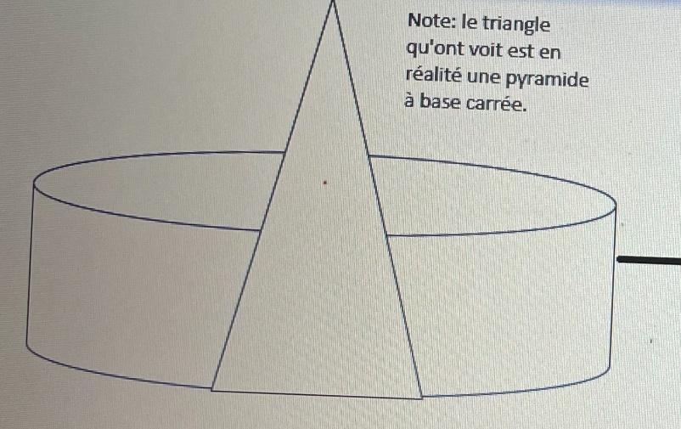
Examples:
- Creating a square pyramidal cavity.
- Removing a triangular pyramidal section.
- Creating a pyramid-shaped depression.
- Removing multiple pyramid-shaped portions.

Spherical Subtraction from a Cylinder
# Source: AI Source: Provided by: [Data Path: Persons Table -> ID Column: 1, Name_En Column: Motasem Essam] -> From: [ChatGPT] on [7/25/2026]
This type is formed by removing a spherical portion or spherical section from an original cylinder.
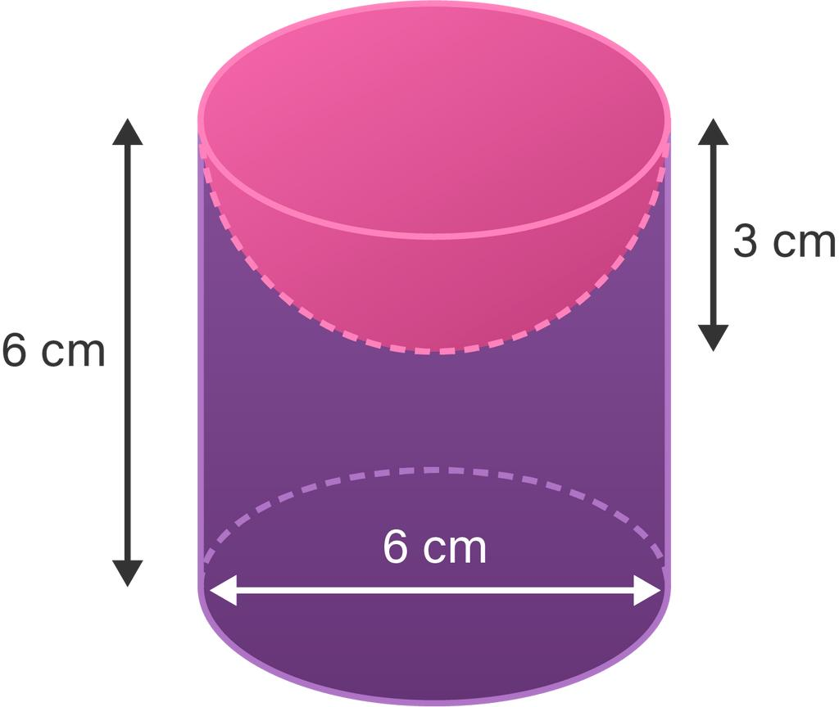
Examples:
- Creating a spherical cavity.
- Removing a hemispherical depression.
- Creating a spherical opening.
- Removing multiple spherical sections.

Multiple-Shape Subtraction from a Cylinder
# Source: AI Source: Provided by: [Data Path: Persons Table -> ID Column: 1, Name_En Column: Motasem Essam] -> From: [ChatGPT] on [7/25/2026]
This type is formed by removing two or more portions of different geometric shapes from an original cylinder.
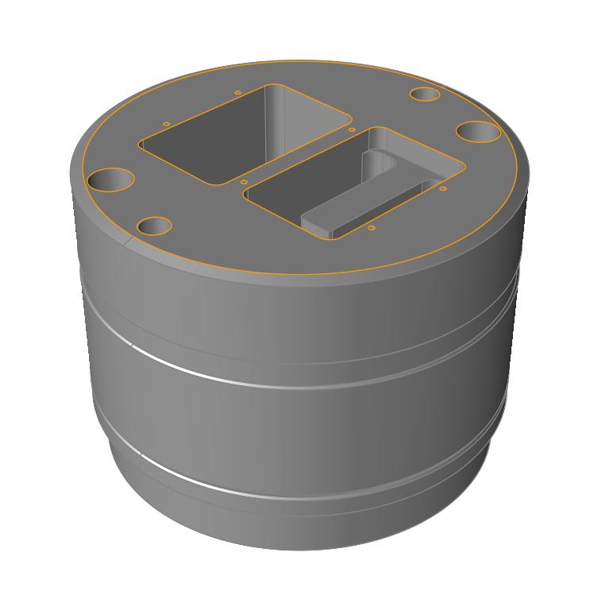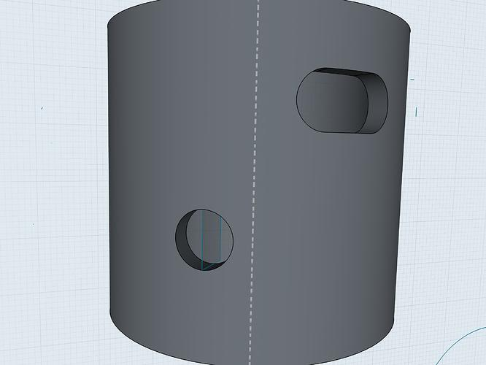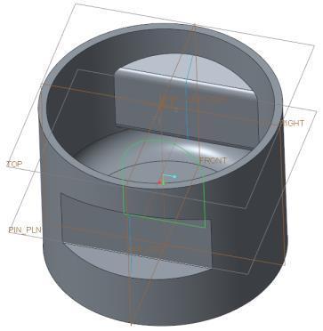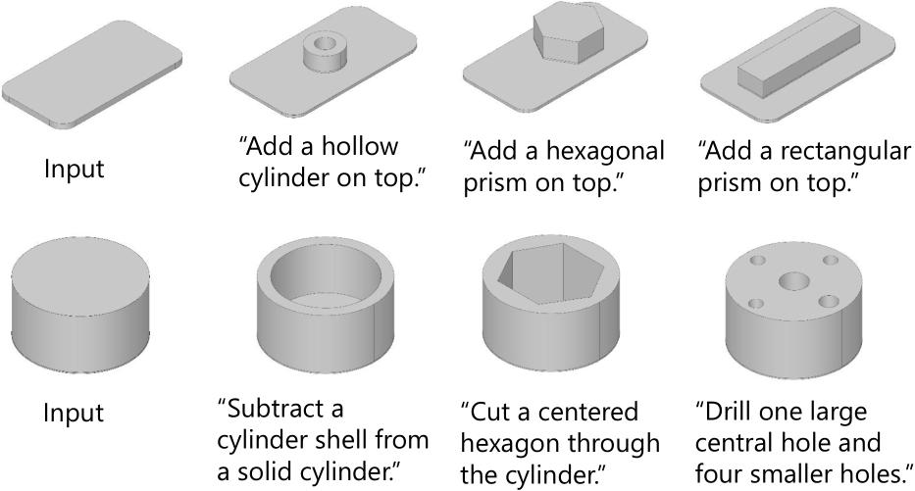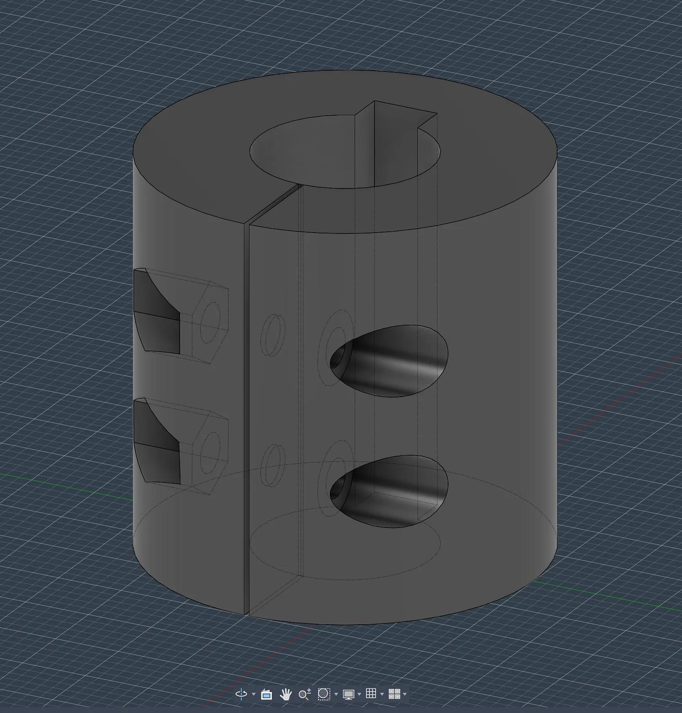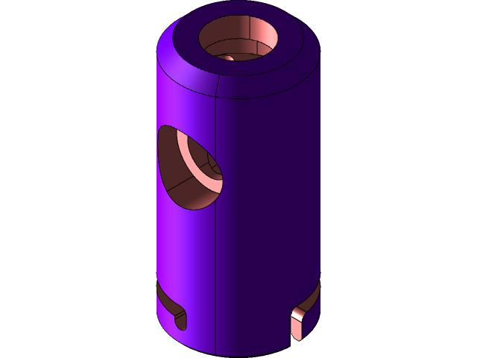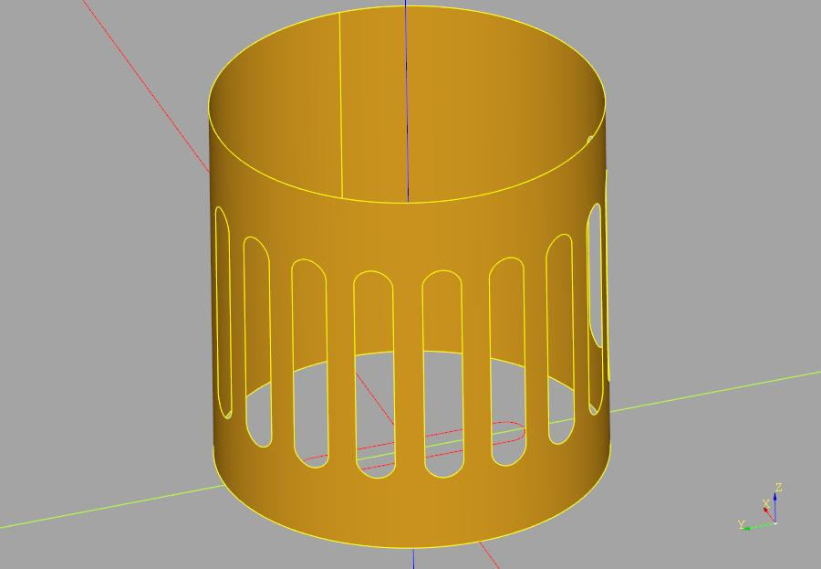
Examples:
- Cylindrical hole + rectangular slot.
- Conical depression + cylindrical through-hole.
- Spherical cavity + rectangular groove.
- Multiple cylindrical and polygonal cutouts.

Classification by Subtraction Location
# Source: AI Source: Provided by: [Data Path: Persons Table -> ID Column: 1, Name_En Column: Motasem Essam] -> From: [ChatGPT] on [7/25/2026]
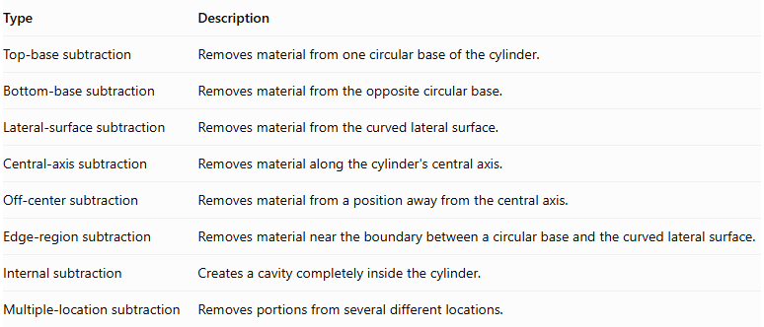
Type | Description
Top-base subtraction | Removes material from one circular base of the cylinder.
Bottom-base subtraction | Removes material from the opposite circular base.
Lateral-surface subtraction | Removes material from the curved lateral surface.
Central-axis subtraction | Removes material along the cylinder's central axis.
Off-center subtraction | Removes material from a position away from the central axis.
Edge-region subtraction | Removes material near the boundary between a circular base and the curved lateral surface.
Internal subtraction | Creates a cavity completely inside the cylinder.
Multiple-location subtraction | Removes portions from several different locations.

Classification by Subtraction Method
# Source: AI Source: Provided by: [Data Path: Persons Table -> ID Column: 1, Name_En Column: Motasem Essam] -> From: [ChatGPT] on [7/25/2026]
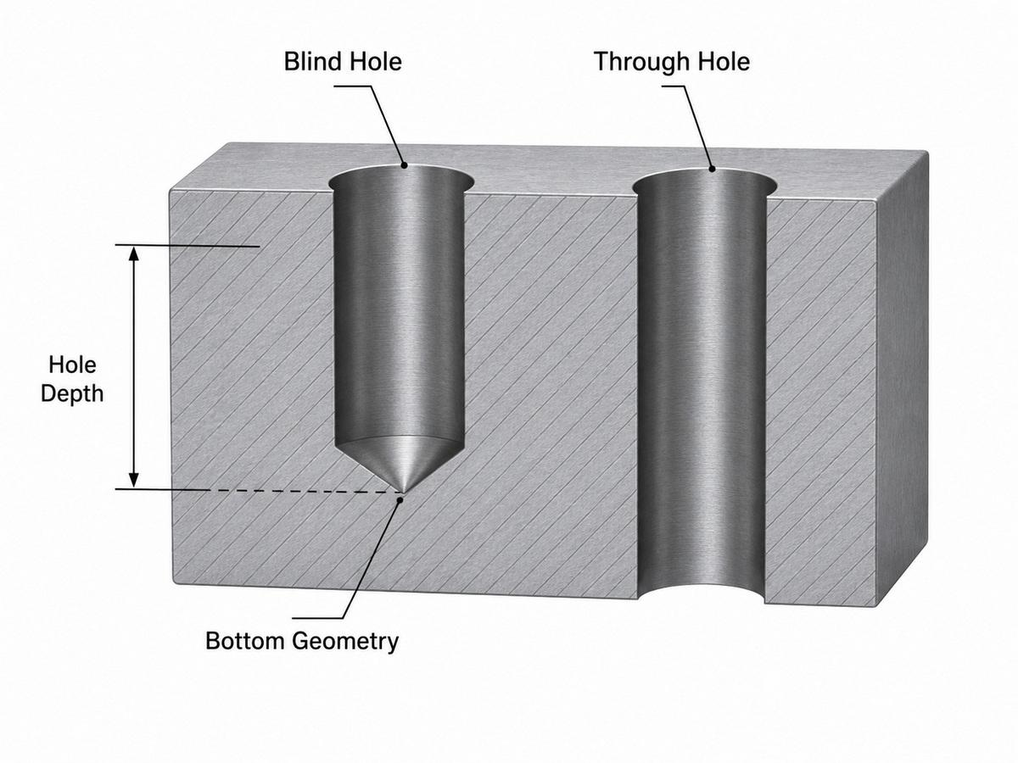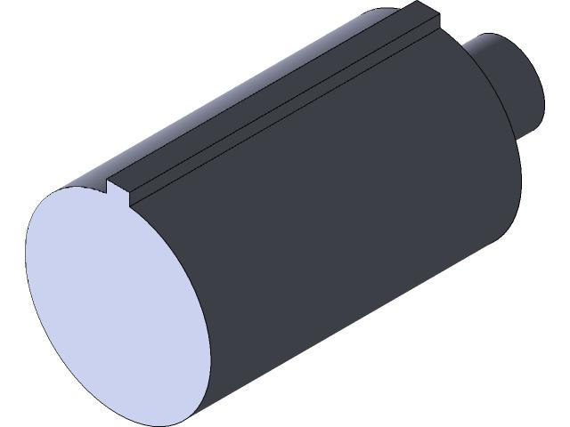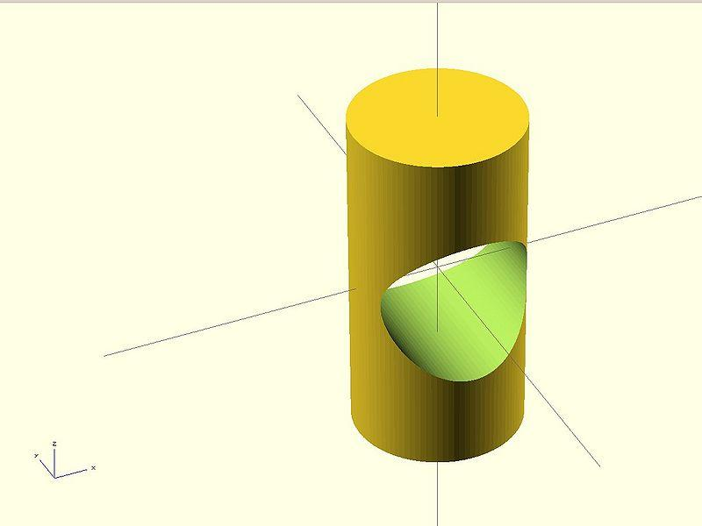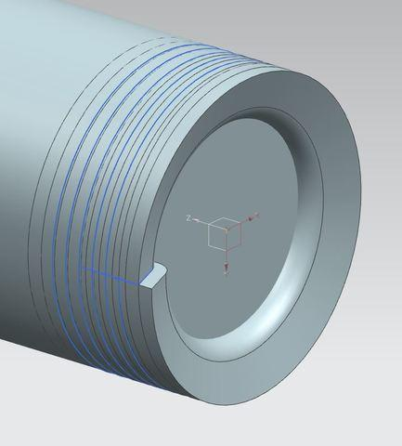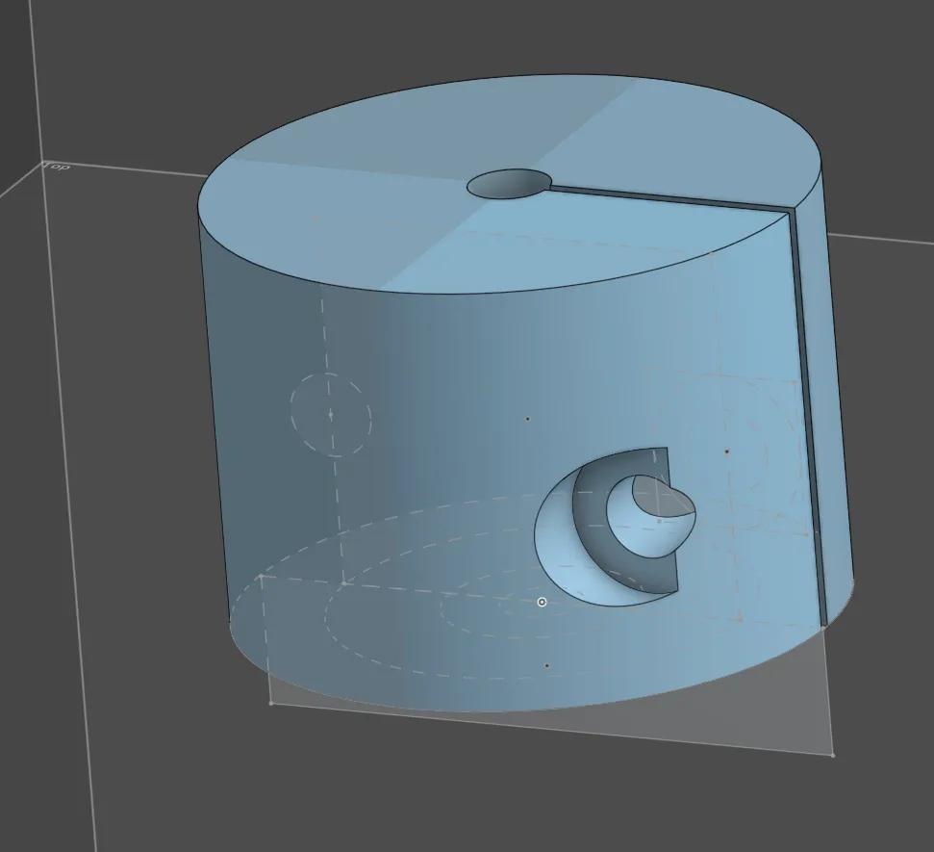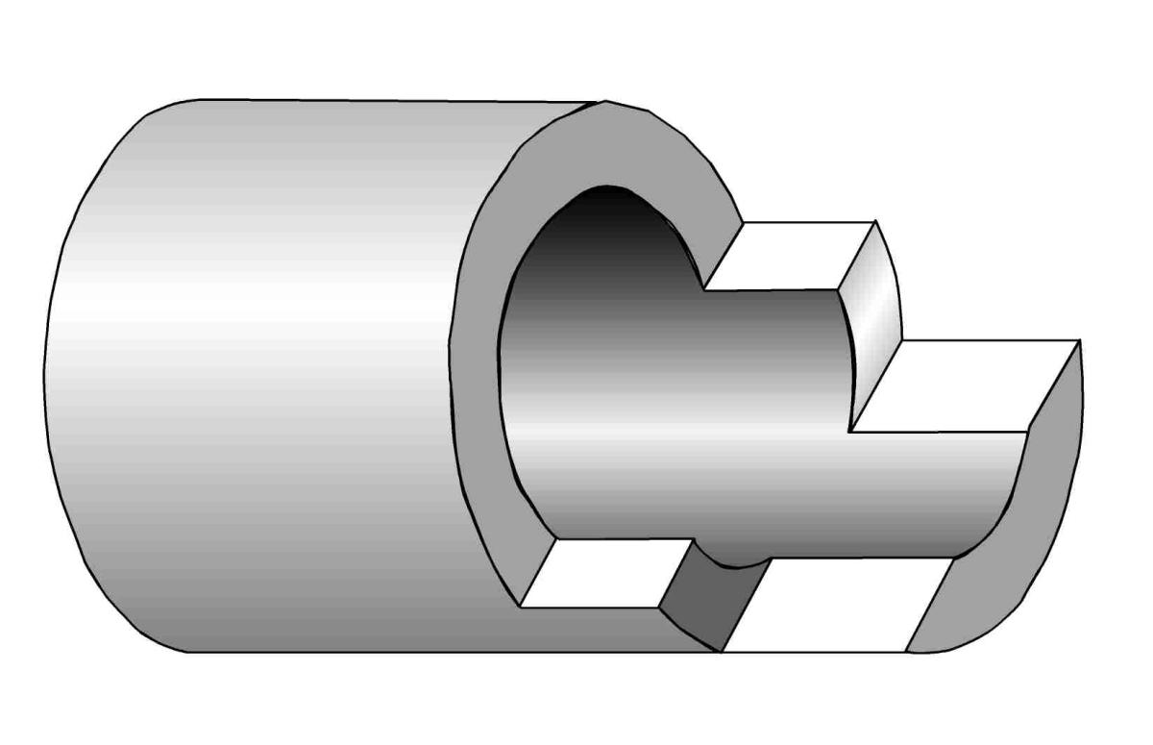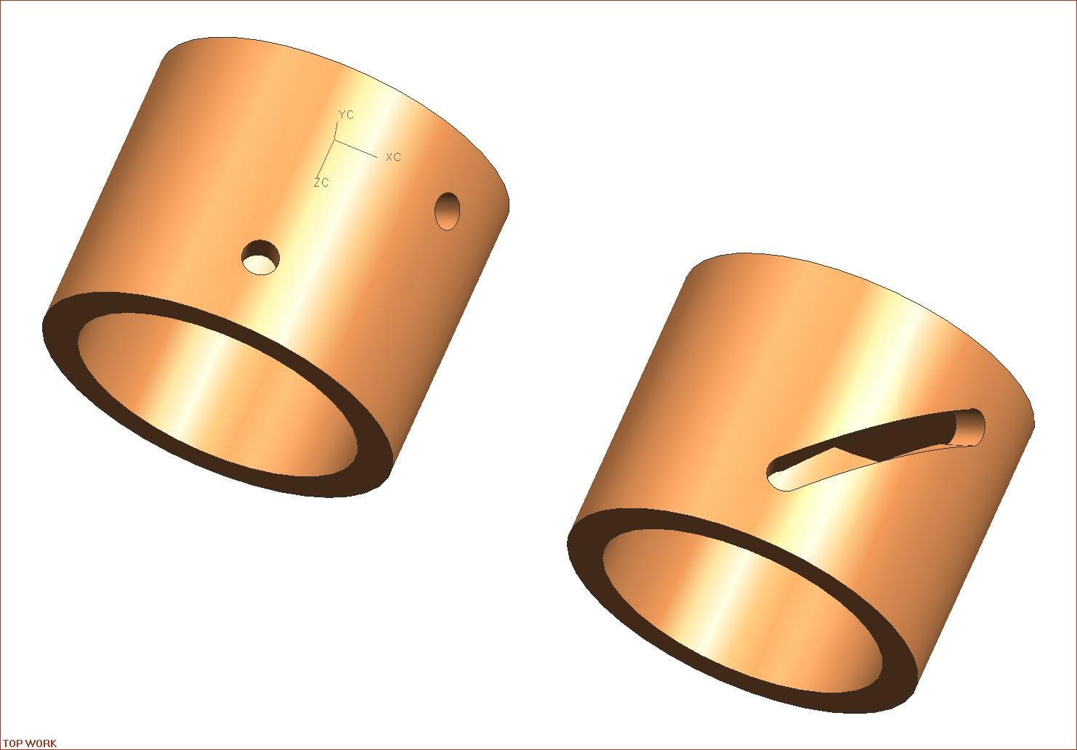
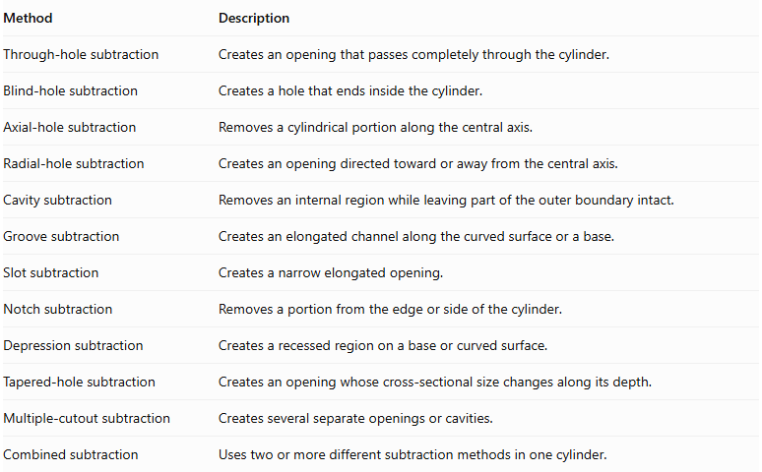
Method | Description
Through-hole subtraction | Creates an opening that passes completely through the cylinder.
Blind-hole subtraction | Creates a hole that ends inside the cylinder.
Axial-hole subtraction | Removes a cylindrical portion along the central axis.
Radial-hole subtraction | Creates an opening directed toward or away from the central axis.
Cavity subtraction | Removes an internal region while leaving part of the outer boundary intact.
Groove subtraction | Creates an elongated channel along the curved surface or a base.
Slot subtraction | Creates a narrow elongated opening.
Notch subtraction | Removes a portion from the edge or side of the cylinder.
Depression subtraction | Creates a recessed region on a base or curved surface.
Tapered-hole subtraction | Creates an opening whose cross-sectional size changes along its depth.
Multiple-cutout subtraction | Creates several separate openings or cavities.
Combined subtraction | Uses two or more different subtraction methods in one cylinder.

Classification by Number and Arrangement of Removed Portions
# Source: AI Source: Provided by: [Data Path: Persons Table -> ID Column: 1, Name_En Column: Motasem Essam] -> From: [ChatGPT] on [7/25/2026]
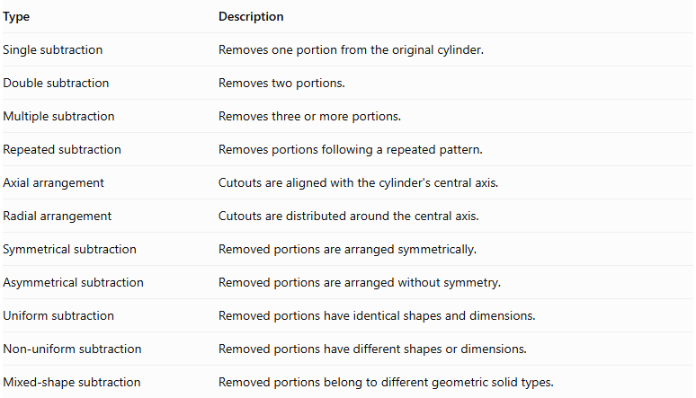
Type | Description
Single subtraction | Removes one portion from the original cylinder.
Double subtraction | Removes two portions.
Multiple subtraction | Removes three or more portions.
Repeated subtraction | Removes portions following a repeated pattern.
Axial arrangement | Cutouts are aligned with the cylinder's central axis.
Radial arrangement | Cutouts are distributed around the central axis.
Symmetrical subtraction | Removed portions are arranged symmetrically.
Asymmetrical subtraction | Removed portions are arranged without symmetry.
Uniform subtraction | Removed portions have identical shapes and dimensions.
Non-uniform subtraction | Removed portions have different shapes or dimensions.
Mixed-shape subtraction | Removed portions belong to different geometric solid types.

Mathematical Properties and Formulas

Volume of a Cylinder-Based Solid After Subtraction
# Source: AI Source: Provided by: [Data Path: Persons Table -> ID Column: 1, Name_En Column: Motasem Essam] -> From: [ChatGPT] on [7/25/2026]
The remaining volume is calculated by subtracting the removed volume from the original cylinder volume.
$$\boxed{V_{remaining}=V_{original}-V_{removed}}$$
For multiple non-overlapping removed portions:
$$V_{remaining}=V_{original}-\sum_{i=1}^{n}{V_{i}}$$
The volume of the original cylinder is:
$$V_{cylinder}=πR^{2}H$$
Where:
- $R$ = original cylinder radius.
- $H$ = original cylinder height.
Useful formulas for removed portions:
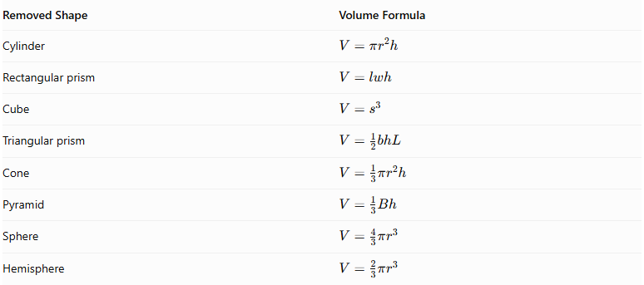
Removed Shape | Volume Formula
Cylinder | $$V=πr^{2}h$$
Rectangular prism | $$V=lwh$$
Cube | $$V=s^{3}$$
Triangular prism | $$V=\frac{1}{2}bhL$$
Cone | $$V=\frac{1}{3}πr^{2}h$$
Pyramid | $$V=\frac{1}{3}Bh$$
Sphere | $$V=\frac{4}{3}πr^{3}$$
Hemisphere | $$V=\frac{2}{3}πr^{3}$$
For a coaxial cylindrical through-hole:
$$\boxed{V_{remaining}=π(R^{2}-r^{2})H}$$
Here, $r$ is the radius of the removed cylindrical portion, and the hole extends through the entire height.
If removed portions overlap, their common regions must not be subtracted twice.

Surface Area After Subtraction
# Source: AI Source: Provided by: [Data Path: Persons Table -> ID Column: 1, Name_En Column: Motasem Essam] -> From: [ChatGPT] on [7/25/2026]
Surface area changes according to the original surfaces removed and the new surfaces exposed by the subtraction.
$${SA}_{remaining}={SA}_{original remaining}+{SA}_{newly exposed}$$
The original cylinder surface area is:
$${SA}_{cylinder}=2πR^{2}+2πRH$$
Where:
- $2πR^{2}$ = area of the two circular bases.
- $2πRH$ = curved lateral surface area.
For a coaxial cylindrical through-hole:
$${SA}_{remaining}=2π(R^{2}-r^{2})+2πRH+2πrH$$
This includes:
- Two remaining annular base surfaces.
- The original outer curved lateral surface.
- The newly exposed inner cylindrical surface.
For a coaxial blind cylindrical cavity:
If the cavity has radius $r$ and depth $d$:
$${SA}_{remaining}={SA}_{original}+2πrd$$
This assumes the cavity is cut into one circular base, does not break through the opposite base, and its opening and flat bottom have equal circular areas.
For other cutout shapes, calculate the actual exposed surfaces and subtract the portions of the original boundary that were removed.

Worked Examples

Example 1: Cylinder with a Coaxial Cylindrical Through-Hole
# Source: AI Source: Provided by: [Data Path: Persons Table -> ID Column: 1, Name_En Column: Motasem Essam] -> From: [ChatGPT] on [7/25/2026]
Given:
- Original cylinder radius = $5 cm$.
- Original cylinder height = $10 cm$.
- Removed cylindrical hole radius = $2 cm$.
- The hole passes completely through the cylinder along its central axis.
Step 1: Calculate the original cylinder volume.
$$V_{original}=πR^{2}H$$
$$=π(5)^{2}(10)=250π{ cm}^{3}$$
Step 2: Calculate the removed cylindrical volume.
$$V_{removed}=πr^{2}H$$
$$=π(2)^{2}(10)=40π{ cm}^{3}$$
Step 3: Calculate the remaining volume.
$$V_{remaining}=250π-40π$$
$$\boxed{V_{remaining}=210π≈659.73{ cm}^{3}}$$
Step 4: Calculate the original cylinder surface area.
$${SA}_{original}=2πR^{2}+2πRH$$
$$=2π(25)+2π(5)(10)$$
$$=150π{ cm}^{2}$$
Step 5: Calculate the new surface area.
The remaining external surfaces include:
- Two annular circular bases:
$$2π(R^{2}-r^{2})=2π(25-4)=42π$$
- Outer curved lateral surface:
$$2πRH=100π$$
- Inner cylindrical curved surface:
$$2πrH=40π$$
Therefore:
$${SA}_{remaining}=42π+100π+40π$$
$$\boxed{{SA}_{remaining}=182π≈571.77{ cm}^{2}}$$
<badge color="success">Final result</badge>
- Remaining Volume ≈ $659.73{ cm}^{3}$
- New Surface Area ≈ $571.77{ cm}^{2}$

Example 2: Cylinder with a Blind Cylindrical Cavity
# Source: AI Source: Provided by: [Data Path: Persons Table -> ID Column: 1, Name_En Column: Motasem Essam] -> From: [ChatGPT] on [7/25/2026]
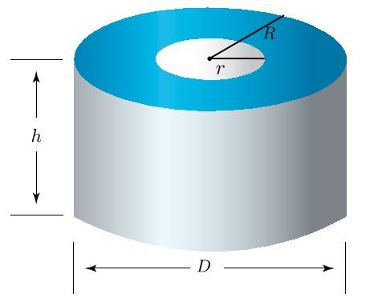
Given:
- Original cylinder radius = $5 cm$.
- Original cylinder height = $8 cm$.
- Cylindrical cavity radius = $2 cm$.
- Cavity depth = $3 cm$.
- The cavity is drilled into the top circular base and does not pass through the cylinder.
Step 1: Calculate the original cylinder volume.
$$V_{original}=πR^{2}H$$
$$=π(5)^{2}(8)=200π{ cm}^{3}$$
Step 2: Calculate the removed cylindrical volume.
$$V_{removed}=πr^{2}d$$
$$=π(2)^{2}(3)=12π{ cm}^{3}$$
Step 3: Calculate the remaining volume.
$$V_{remaining}=200π-12π$$
$$\boxed{V_{remaining}=188π≈590.62{ cm}^{3}}$$
Step 4: Calculate the original cylinder surface area.
$${SA}_{original}=2πR^{2}+2πRH$$
$$=2π(25)+2π(5)(8)$$
$$=130π{ cm}^{2}$$
Step 5: Calculate the new surface area.
The cavity creates a new internal cylindrical curved surface.
The circular opening and the cavity bottom have equal areas, so their surface area changes cancel each other.
New internal curved surface:
$${SA}_{cavity}=2πrd$$
$$=2π(2)(3)=12π{ cm}^{2}$$
Therefore:
$${SA}_{remaining}=130π+12π$$
$$\boxed{{SA}_{remaining}=142π≈446.11{ cm}^{2}}$$
<badge color="success">Final result</badge>
- Remaining Volume ≈ $590.62{ cm}^{3}$
- New Surface Area ≈ $446.11{ cm}^{2}$

Important Characteristics
# Source: AI Source: Provided by: [Data Path: Persons Table -> ID Column: 1, Name_En Column: Motasem Essam] -> From: [ChatGPT] on [7/25/2026]
- Original Cylinder: The starting solid is a cylinder or cylinder-based structure.
- Material Removal: One or more geometric portions are removed from the original cylinder.
- Variable Cutout Shapes: Removed portions may be cylindrical, rectangular, triangular, conical, pyramidal, or spherical.
- Different Cutout Locations: Material can be removed from circular bases, curved lateral surfaces, or internal regions.
- Axial and Radial Openings: Cutouts may follow the central axis or extend in radial directions.
- New Internal Surfaces: Subtraction creates additional cylindrical walls, cavity bottoms, and other surfaces.
- Reduced Volume: Removing material decreases the volume of the original cylinder.
- Variable Surface Area: Surface area may increase or decrease depending on the shape and position of the cutout.
- Through and Blind Openings: Cutouts may pass completely through the cylinder or terminate inside it.
- Multiple Cutouts: A cylinder may contain several openings, grooves, cavities, or slots.
- Hollow Structures: Cylindrical subtraction can produce hollow cylindrical solids and tubular structures.
- Complex Geometry: Combining different subtraction operations creates more complicated cylindrical structures.

Comparison with Other Types of Composite Solids Formed by Subtraction
# Source: AI Source: Provided by: [Data Path: Persons Table -> ID Column: 1, Name_En Column: Motasem Essam] -> From: [ChatGPT] on [7/25/2026]
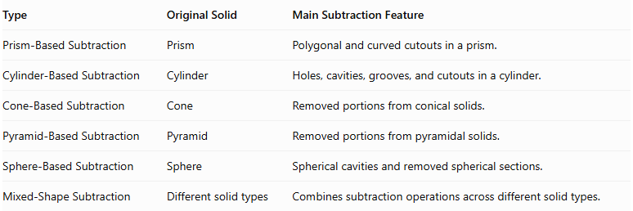
Type | Original Solid | Main Subtraction Feature
Prism-Based Subtraction | Prism | Polygonal and curved cutouts in a prism.
Cylinder-Based Subtraction | Cylinder | Holes, cavities, grooves, and cutouts in a cylinder.
Cone-Based Subtraction | Cone | Removed portions from conical solids.
Pyramid-Based Subtraction | Pyramid | Removed portions from pyramidal solids.
Sphere-Based Subtraction | Sphere | Spherical cavities and removed spherical sections.
Mixed-Shape Subtraction | Different solid types | Combines subtraction operations across different solid types.

Applications
# Source: AI Source: Provided by: [Data Path: Persons Table -> ID Column: 1, Name_En Column: Motasem Essam] -> From: [ChatGPT] on [7/25/2026]
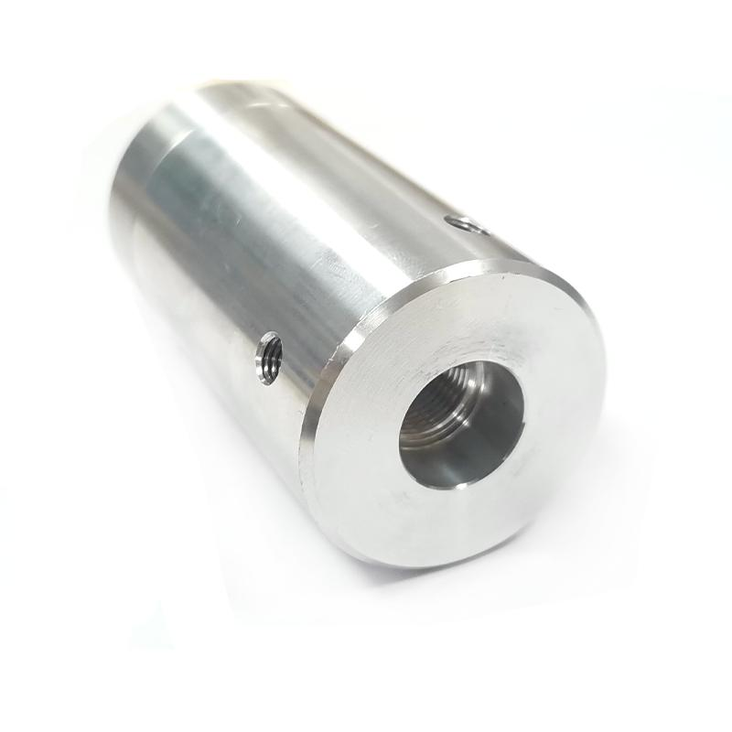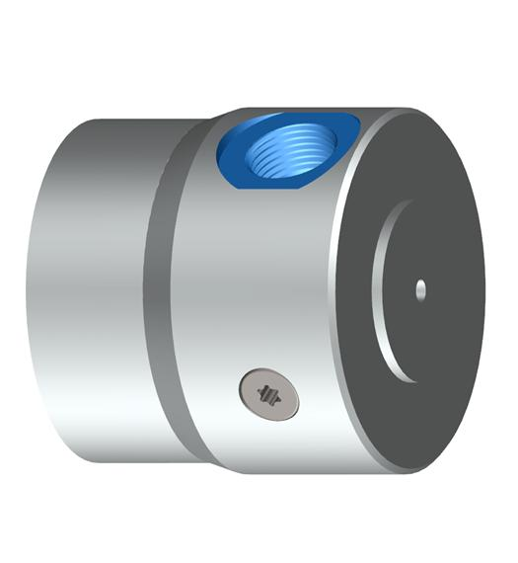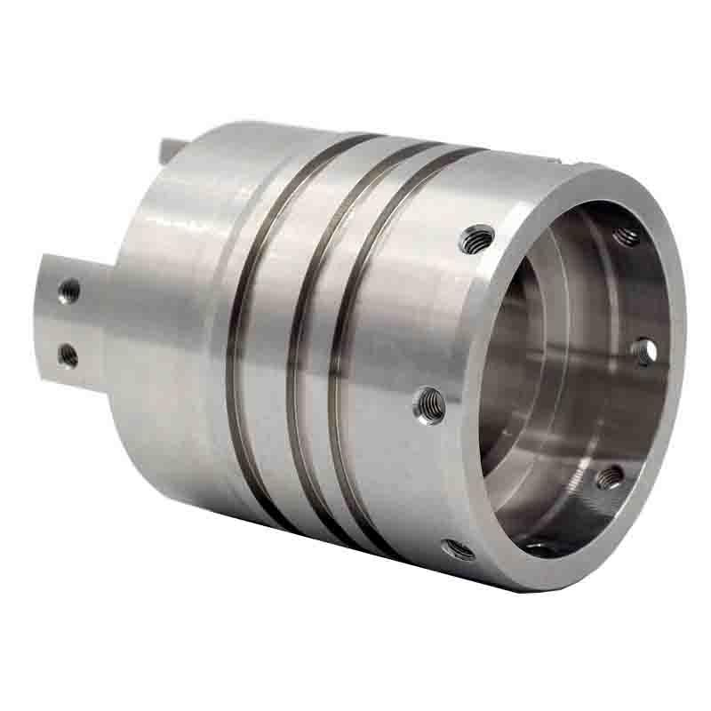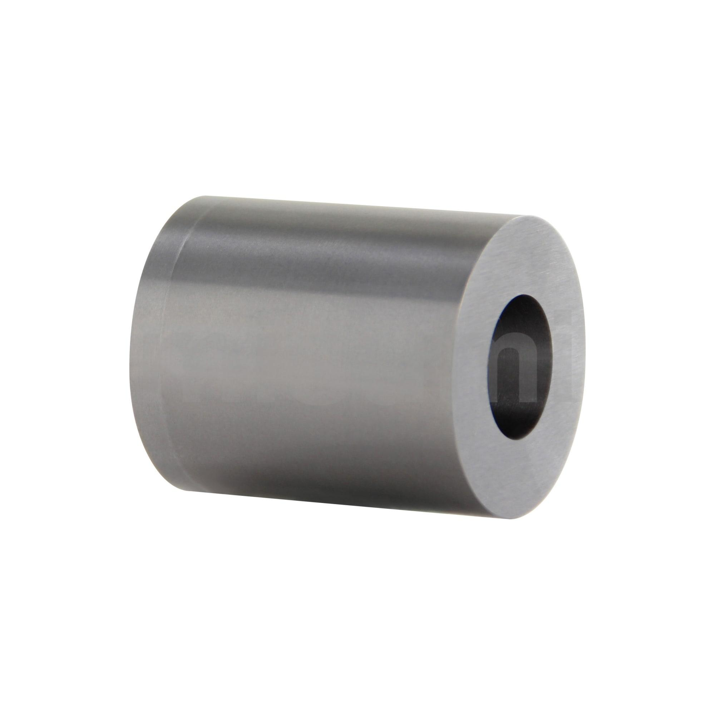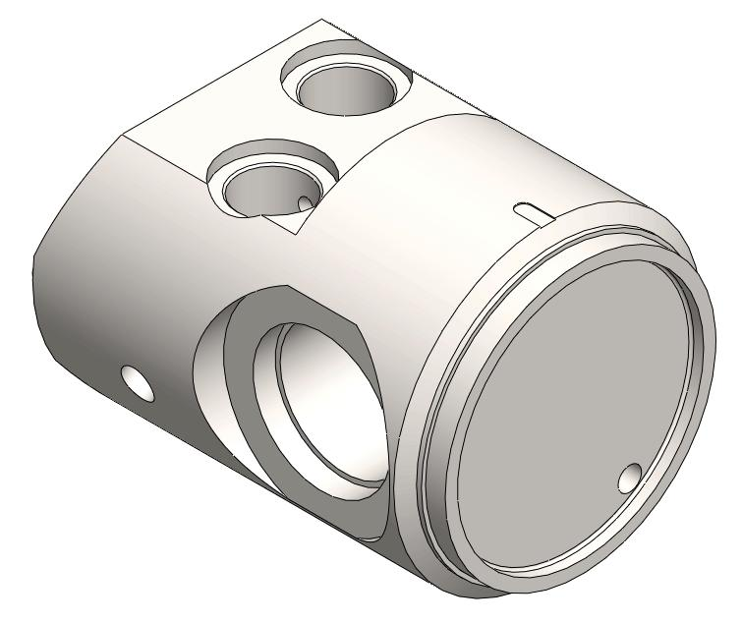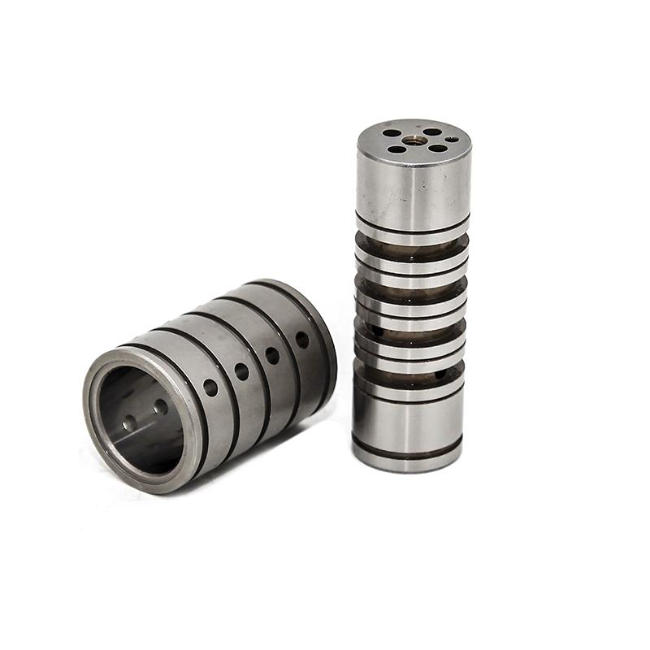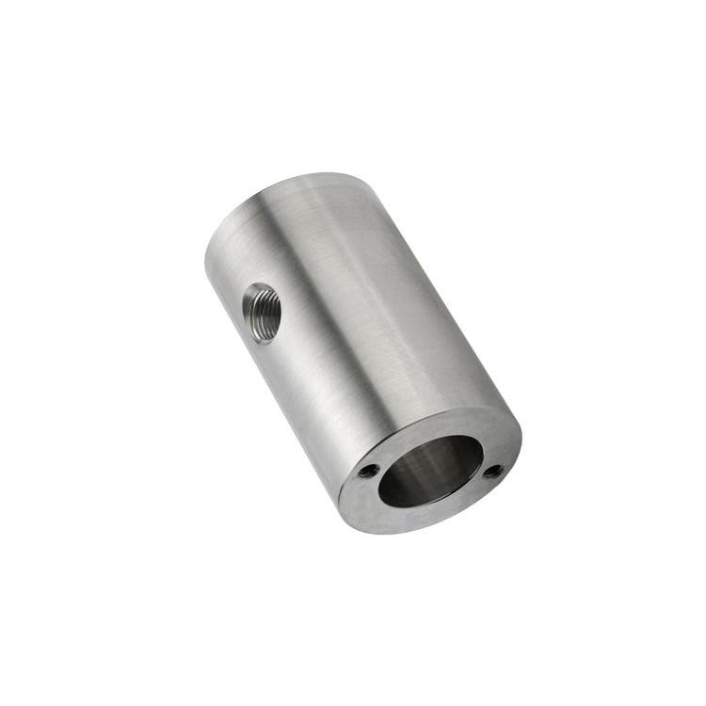
Cylinder-based subtraction is used in several fields:
- Mechanical Engineering: Creating cylindrical shafts, hollow components, and machine parts.
- Manufacturing: Producing cylindrical holes, grooves, slots, and cavities through drilling, turning, and milling.
- Automotive Engineering: Manufacturing engine components, shafts, pistons, and cylindrical housings.
- Hydraulic Systems: Creating internal passages and radial openings in cylindrical components.
- Construction: Producing cylindrical structural components with openings and cavities.
- Product Design: Creating hollow containers, cylindrical housings, and specialized components.
- Computer-Aided Design (CAD): Modeling cylindrical objects using Boolean subtraction operations.
- Mathematical Education: Studying cylindrical volume, surface area, and cross-sectional changes.

Key Points
# Source: AI Source: Provided by: [Data Path: Persons Table -> ID Column: 1, Name_En Column: Motasem Essam] -> From: [ChatGPT] on [7/25/2026]
- Cylinder-based subtraction removes one or more geometric portions from an original cylinder.
- Removed portions can include cylinders, prisms, cones, pyramids, and spheres.
- Common subtraction methods include through-holes, blind holes, axial holes, radial holes, grooves, slots, and cavities.
- The remaining volume is calculated by subtracting the removed volume from the original cylinder volume.
- Overlapping removed regions must be handled carefully.
- Surface area calculations must account for the original surfaces removed and the new surfaces exposed.
- Removing material does not necessarily decrease the total surface area.
- Cylindrical subtraction can create hollow structures and complex internal passages.

Conclusion
# Source: AI Source: Provided by: [Data Path: Persons Table -> ID Column: 1, Name_En Column: Motasem Essam] -> From: [ChatGPT] on [7/25/2026]
Cylinder-Based Subtraction is an important category of composite solids formed by subtraction. It involves removing geometric portions from an original cylinder to create modified structures containing holes, cavities, grooves, slots, and other features.
The removed portions may have different shapes, dimensions, and orientations. Understanding this process makes it possible to calculate remaining volume, determine changes in external surface area, and analyze complex cylindrical structures used in engineering, manufacturing, construction, and computer-aided design.

